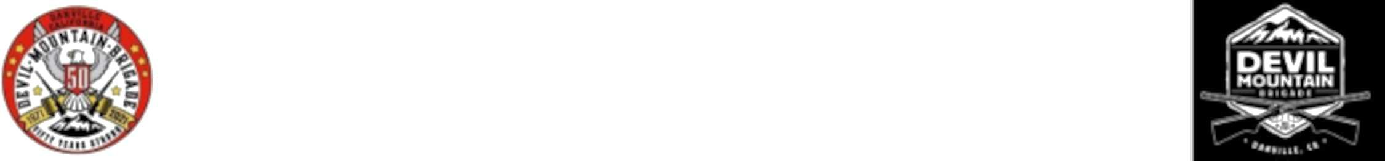

June 30, 2025 is the due date for renewing your Devil Mountain Brigade (DMB) membership. The annual membership dues are *$*75. Because of ever-increasing scrutiny from the public as well as our insurance company it is necessary to annually review our parade safety rules, sign them, and return this copy along with your renewal fee to the recruitment officer.

# Devil Mountain Brigade Rules

## Parade Uniform

* + 1. ECV attire is not to be worn when representing the DMB before, during, or after a shoot of any kind. This includes out-of-town parades and events.
    2. The Devil Mountain Brigade will remove their vests. They will wear their existing red T-shirts that are imprinted ”Devil Mountain Brigade” and have a silhouette of Mt. Diablo with crossed shotguns superimposed over it. The polo shirts with collar or tank tops, are not parade uniform. Each member will pick his own hat to wear, but will not be allowed any Clamper regalia on it. Black pants or Levi’s will complete the uniform.

## Other Things to Keep in Mind

* + 1. We are all aware of the increasing controversy over guns. We have an opportunity to be a good role model at very public events. We are the last of what use to be many shotgun brigades in existence. We are grown men having fun, and need to convey that to the crowd by smiling and waving, so that we are not mistaken for some sort of militia group.
    2. If you wish to receive a laminated membership card you need to have your dues received at least by the end of June, as we only make them up once a year.
    3. We sometimes do a 21 gun memorial salute to respect a brigade member or Clamper dignitary at the request of a family member. We do not solicit this service.

## Gun Safety

* + 1. Only DMB functions authorized by the Commander or Vice Commander will be recognized as official func- tions. No DMB member shall represent the DMB or wear DMB logo in any shoot not authorized by the Commander or Vice Commander.
    2. There is zero tolerance of violations of gun safety rules. A shooter who violates gun safety will be asked by any officer of the DMB to immediately lock his gun in a vehicle and not participate in that day’s shoot. All NRA gun safety rules shall be observed at all times
    3. Always treat your gun as though it is loaded, even if you believe it to be unloaded. Keep your gun pointed in a safe direction at all times.
    4. No ammunition shall be brought to a DMB event by members. All blanks will be provided on shoot day by the DMB. All unused shells need to be returned to the quartermaster.
    5. Open breach guns should be ”open” at all times prior to the start and finish of parade. All guns shall have the safety ON at all times.
    6. No guns should be carried ”rested” over the shoulder.
    7. Guns should be pointed straight up or straight down at all times. Use common sense.
    8. No alcohol or drugs use, including over the counter or prescription drugs that may effect you, should occur prior to a shoot.
    9. Guns will be inspected. Your gun must be cleaned and oiled prior to each shoot.

## During a Shoot

* + 1. Gun safety should be your utmost concern at all times!
    2. Guns should not be loaded until ordered by the Commander.
    3. Only one shell is to be loaded at a time, regardless of how many your gun may hold.
    4. While loading guns always point barrel up in a safe direction.
    5. Gun safety shall remain on until the Commander blows the whistle.
    6. After you shoot, eject the shell and reload (with the safety on).
    7. Even while gun is unloaded, Keep it Pointed in a Safe Direction.
    8. Once the Commander or Vice Commander says that the shoot is over, all guns should be placed in a locked vehicle, not hand carried back through town.

# Release

I have read all of the above rules and understand them. I take full responsibility for my actions while at all DMB functions.

|  |  |  |  |  |  |  |  |  |
| --- | --- | --- | --- | --- | --- | --- | --- | --- |
| Print Name |  |  |  |  |  | Date |  | |
| Address |  |  |  |  |  |  |  |  |
| City |  |  |  | State |  | Zip |  |  |
| Phone |  | Email |  |  |  |  |  |  |
| Sponsor |  |  |  |  |  |  |  |  |
| Signed |  |  |  |  |  |  |  |  |

Make your *$*75 dues check payable to Devil Mountain Brigade and send it to the recruitment officer:

Darryl Allen PO Box 1642

Martinez, CA 94553